**Covid PDS Plus: An e-PDS & healthcare platform towards pandemic restoration**

Vedant Shrivastava, KIIT University, Bhubaneswar, Odisha - 751024, India. Email: [vedantshrivastava466@gmail.com](mailto:vedantshrivastava466@gmail.com)

**Abstract**

During the COVID-19 crisis, millions of migrant daily wage workers and homeless around the world face food insecurity. This could force migrants to travel during the pandemic, exposing them to health risks and accelerating the spread of the virus. Anecdotal evidence demonstrates the importance of enforcing food security and distribution policies to tide the crisis. However, the effects of these policies on containing mobility during the crisis remain unknown. This paper presents the outlook and prototype build of an e-PDS and healthcare platform created using complete technology enabled platform to connect the stakeholders i.e. People, Government, NGOs, which works in real-time such that social distancing and other measures are kept in check.

**Keywords - public distribution system, e-pds, covid, healthcare, patient triaging.**

1. **Introduction**

In a largely unexpected announcement at 8 p.m. on March 24, 2020, Prime Minister Narendra Modi announced that India would go into a 21-day lockdown to combat the spread of COVID-19. “Every state, every district, every lane, every village will be under lockdown,” said the Prime Minister. Many of India’s migrant workers, who number more than 100 million and represent over 20% of the country’s workforce, were stranded far from home. As many of these migrant workers have minimal savings and limited access to social benefits, food security and distribution is a critical concern. Some migrant workers walked hundreds of miles back to their hometowns following the lockdown announcement. India had set up the Public Distribution System (PDS) in 1944 to deliver subsidized food to citizens. Using “ration cards,” people may purchase food at their local ration shops (also known as “fair price shops”) at subsidized rates.

Today in India, there are about 230 million ration card holders and 534,000 ration shops, 88% of which are digitized and possess electronic point of sales (EPoS) machines. During the lockdown, ration card holders are allowed to purchase food at cheaper rates and/or receive free food distributed by the government (at least 5 kg of wheat or rice and 1 kg of legumes). Despite the existing food distribution measures, many citizens, especially migrant workers, were left without access to these benefits. This is because, historically, ration cards could only be used in the card holder’s hometown ration shop. In recent years, some states have made ration cards portable, allowing card holders to procure subsidized food at ration shops outside their hometowns.

Thus in this paper we study an application/website platform which bridges the gap between the distributors and the customers is the necessity of the hour. Here, using ML algorithms, we are calculating the INCOME INDEX of the customers for understanding their economic condition. This helps us to predict the % of subsidies to be given. The application further features the portal where citizens can report homeless people, the information would be immediately transferred to connected NGOs/ organizations.

The Revenue earned from the e-PDS platform is to be used towards social welfare as COVID Healthcare+ in Phase two of business model as Social Responsibility. Here the implementation caters the target market Rural India. The working would be suvh that in-house treatment would be provided to COVID positive cases where healthcare facilities aren’t available. ASHA (Accredited Social Health Activist) workers will be hired and trained, to provide At-Home Patient Triaging, to the COVID Positive cases in Rural India and the COVID-19 spread to be periodically monitored.

Figure 1: Logo Design.



1. **Methodology**

The current scenario features the government who has given contracts to reputed vendors for distribution of daily eatables and ration among the people who are suffering, during the lockdown, at SUBSIDIZED RATES according to their income. The vendors have set up their distribution points throughout the country, but are facing problems in management during distribution, as there are a few workforce available at every distribution point to cater the entire locality, which leads to violation of Social Distancing rule. The government has arranged quarters for the homeless people, as they are at a high risk of getting contaminated. But there is no medium at present, to connect them together due to the technological barrier. The citizens are helping the NGOs to locate such people, but at a slow rate.

* 1. *The Solution and Business Model:*

In this study we quantify about, Our solution to the current scenario includes an application platform which bridges the gap between the distributors and the customers. Using ML algorithms, we are calculating the INCOME INDEX of the customers for understanding their economic condition. This helps us to predict the % of subsidies to be given. The application features the portal where citizens can report homeless people, the information would be immediately transferred to connected NGOs/ organizations.

* 1. *Application WorkFlow:*

The User Side Workflow Explained.

1. Includes a One Time User Sign-up. After which Cross-verification Of Details Takes place. Moreover Prediction of an INCOME INDEX after analysing Income takes place.
2. User orders the items required for the next day, a day before, in the app. On the basis of the INCOME INDEX, the order is either free or eligible for discount.
3. Next day morning, the user receives a QR Code along with a confirmation from the local distributor.
4. At the distribution point, the user shows the QR Code to the merchant, pays the amount(if any) and collects the items.

The Distributor Side Workflow Explained.

1. Registration of the distribution points in the App will take place, Marking the area to be catered by each Distribution point.
2. An appointed Point Manager can see the orders for the next day after logging in and keeps track of the money collected as well as perform daily analysis of data.
3. When the QR Code of the customer is scanned, the amount to be payed gets displayed.
4. At the end of each day, Point manager is given access to read the responses received from the people and will get a visual analysis of the data.

Figure 2: Application Workflow.

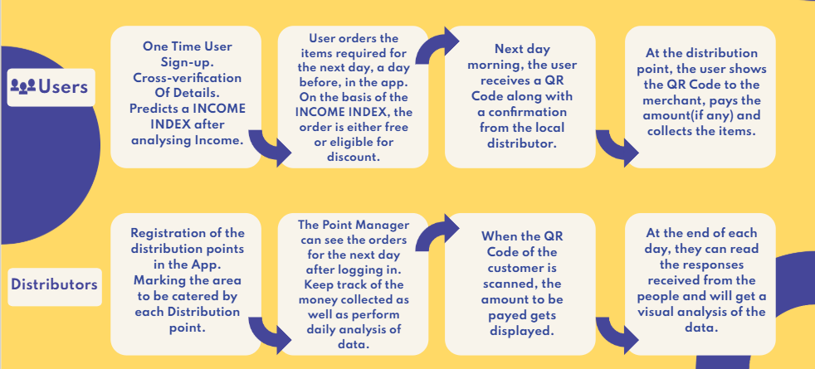

* 1. *Target Market:*

The Poor & Middle Class:

The Daily Wage Workers are the most affected due to the lock-down situation. We are taking the opportunity of providing them food at low cost considering their economic condition.

The Homeless:

These people have high chances of getting contaminated due to their surrounding hygiene. We are therefore encouraging citizens to report such cases in our Application. This information is shared with the Local Authorities/NGOs, to provide them residence.

* 1. *Technology Stacks and Tools Used:*
* A MERN Stack Web Application using NGINX as Reverse Proxy and Load Balancer[3].
* Complete User Interface of the Mobile Application using Adobe XD.
* Utilizing the computation power of Spark for Predictive Analytics.
* Containerizing the Application using Docker for safe and secure deployment on Cloud Engines.
* OpenCV and Pytorch library (packages) used

Figure 3: The Web Architecture.

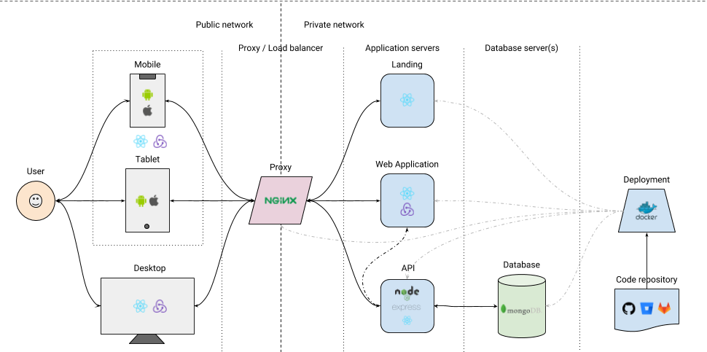

Technical Description:

* The integration and implementation of the source code by the developer with the necessary requirements of society is essential. It is done by the Operations Manager, with use of Docker/Kubernetes for container deployment of the website, and Jenkins for system based automation i.e CI/CD.[4]
* An individual’s annual income results from various factors. Intuitively, it is influenced by the individual’s education level, age, gender, occupation, and etc.
* It is essential that the income take into consideration all factors to necessitate the use of the code to as a Classification Model.
* The first model used calculate the costs of sheltering, while the second model calculates required area as well as costs of housing the population (registered to the website/application).
* Several Classifier models are used to segregate and predict the people of one economic/financial class to the other, to avoid the discriminatory treatment of them as same with respect to their economic background.
* The most important step used by us is the use of Deep Learning concepts and Open Computer Vision for purposes of verification. An audio file and age classifiers are used to avoid wrongful addition of data, which can corrupt the database in terms of information gain.
* The deep learning models implemented can also be used to train or educate the people in these testing times. ASHA(Accredited Social Health Activist) workers also can be trained by using the various models, for example handwashing, hygiene, cleanliness etc.
* Made use of Pytorch/Tensorflow-Keras deep learning libraries to enhance the linear models using Gradient Descent and Backpropagation. Further we have used the Opencv (i.e 'cv2') DNN(Deep Neural network) models for purposes of verifying against pranks while entering data. For Example, the youth of today can play a prank to enter their age as over 80, for both monetary and/or social benefit. But the audio sound (which classifies people above or below the age of 35) segregates them. Further the GAN (Generative Adversarial Network) age determination model will further bring the number to a close value.

Figure 4: Integrating the ML Model with Web Application.

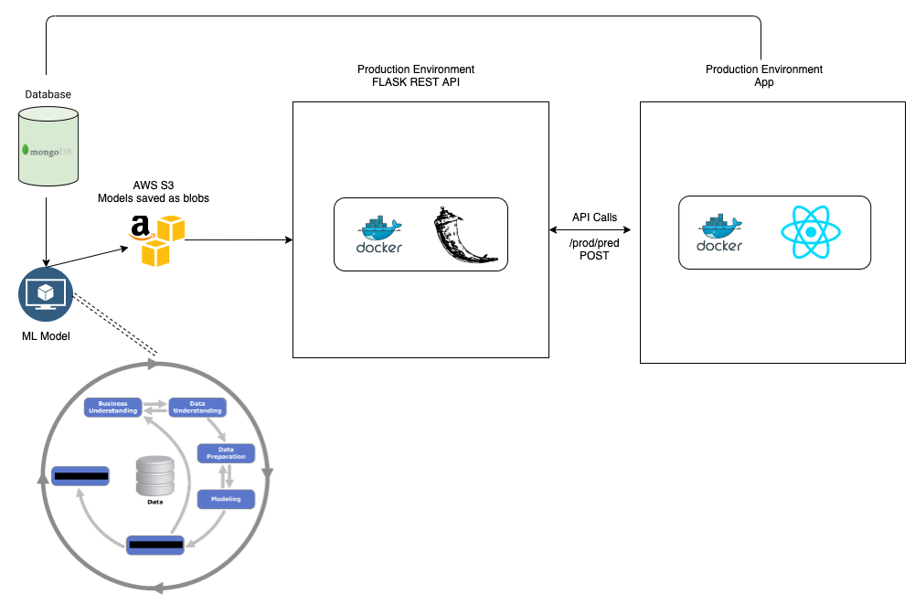

* 1. *Revenue Model*

This Model is further sub-divided into three parts.

1. Interstitial & Admob ads from Google: Daily active users, User Retention, Location of Users.
2. Incentive per head from Distributors: Connecting medium between the Customers & Distributors, Our app can fasten and channelize the distribution.
3. APIs for Analytics: Data after proper Masking of sensitive information, can be used by Analytic companies.cA highly profitable model in the time of Data Monetization.
   1. *Phase 2 : COVID - Healthcare Plus (Towards Social Welfare)*

The Revenue earned from the e-PDS revenue model is to be used towards social welfare as COVID Healthcare Plus in Phase 2 of business model as Social Responsibility. Here the implementation caters the target market Rural India. In-house treatment is to be provided to COVID positive cases where healthcare facilities aren’t available. ASHA (Accredited Social Health Activist) workers are to be appointed and trained, to provide At-Home Patient Triaging, to the COVID Positive cases in Rural India. And the COVID-19 spread is to be periodically monitored.

*Phase 2: Implementation:*

Designed an effective Seven stage Implementation for the Phase 2 Healthcare Model.[5]

Here the first stage corresponds to Building components of the system (apps, bots, educational material). In stage two we contact Stakeholders (government,phone service providers) and focus on Linking the user data with Aadhar Database. Stage three revolves around Dissemination of plan to public (via TV,radio.etc) and training of ASHA Workers. The Beta testing on a target village corresponds to Stage four. After which we Initiate system in other rural areas which is Stage five. Here we require to Modify and scale system for urban areas which is Stage six of Implementation. Finally the Stage seven is about periodically monitoring for community spread of COVID-19 in India.

Figure 5: COVID - Healthcare Plus Implementation.

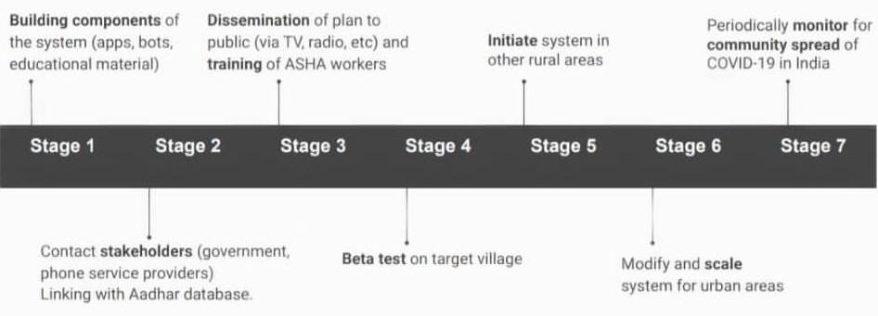

1. **Results and Discussion**

India’s huge population, its density, and very large numbers of poor present an extraordinary challenge for the country’s COVID-19 response, and the Indian government has imposed the largest lockdown in history: 1.3 billion people ordered to shelter in place for 21 days starting March 25. Even China, where the disease originated, ordered a total lockdown in just one area, Hubei Province (while imposing other restrictions throughout the country). Implementing a lockdown in a country of India’s scale is socially, economically, institutionally, and politically very demanding and disproportionately affects the poor, daily wage earners, and other marginalized groups.

Thus COVID-19 exposes a harsh reality: An inadequate and uneven safety net may leave many from these economically vulnerable groups without access to food and other services. This struggle is particularly acute for large numbers of informal sector workers—including self-employed, subcontracted laborers, small farmers, and landless workers. India’s informal sector employs 303 million; The workforces of Uttar Pradesh and Bihar states are more than 80% informal, while even in advanced states like Maharashtra, that number is 70%. COVID-19 may push this group and their families into transient poverty.

Yet compared to those of other countries at a similar income level, India’s social safety net is extensive. An elaborate array of programs exists to assist the poor, including the world’s largest food-based social program, the Public Distribution System (PDS), covering 800 million people. To respond quickly, India is utilizing these existing schemes and reshaping them to address the unique challenges from COVID-19.

Figure 6: Android App UI.

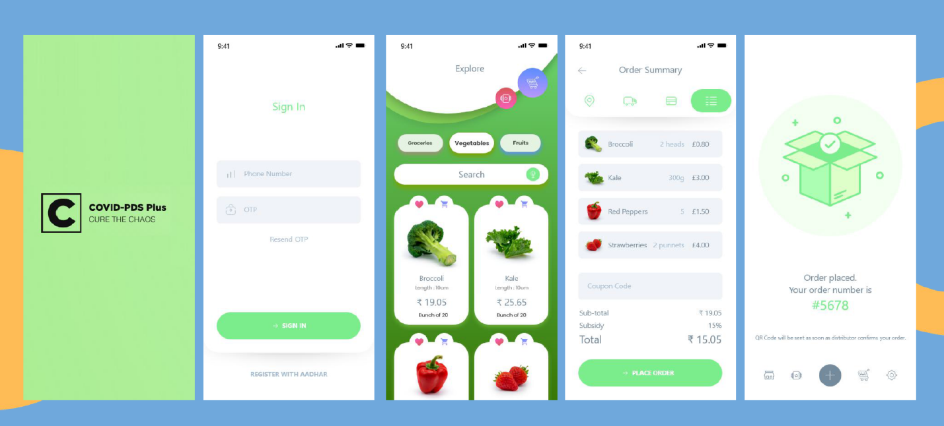

The food-based safety net and COVID-19:

On March 26, the government announced a $22.6 billion relief package with a major food component. PDS plays a key role, providing 5 kg of either rice or wheat and 1 kg of preferred pulses per month free, offered in two installments. (This is in addition to the preexisting entitlement of 5 kg of low-cost wheat/rice per person per month.) The relief package allotment should meet most families’ cereal requirements, but the pulses allocation is likely inadequate, given per month consumption is 4-5 kg. Several states, meanwhile, have announced their own relief packages (table 1). Supplying these relief efforts should not be a problem. Rice, wheat and pulses stocks are adequate to feed the country for now, and harvest of rabi crops is around the corner. This emergency food support is happening at a propitious time.

The Implementation Results:

1. PDS coverage in urban areas is low (about 50%) thus leaving out many urban poor. In response to the pandemic, responsible agencies should quickly expand the list of eligible households. If necessary, the broader coverage could be rolled back after COVID-19 subsides. So far, only the Delhi government has announced that people without ration cards could also get rations. Bihar announced use of direct cash transfers (DCTs), depositing funds to the bank accounts of ration card holders (RCH). Thus the outlook of the application makes this challenge quite an easy task to solve.
2. With commodities prices expected to rise, and the small amounts assigned to pulses in the relief package, ensuring access to adequate diets is problematic which is solved through the e-PDS Platform through the calculation Income Index and thus the required subsidy to be awarded.
3. The Food quality, not just quantity, is maintained. The supply chain deals with the transportation, storage, and distribution of large volumes of food in short time frames during the lockdown to avoid spoilage and contamination.

Figure 7: The Website.

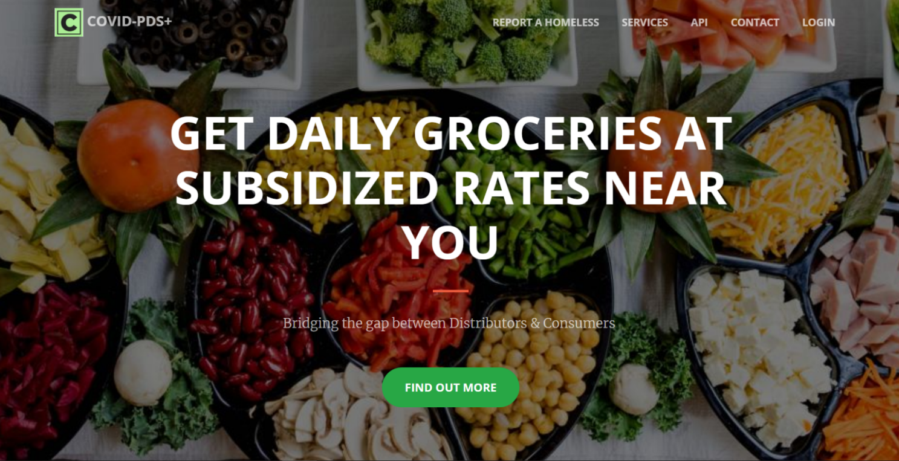

1. **Conclusion**

This research has an aim to provide an easy, effective and complete technology enabled way for the public distribution of food, finding homes for the homeless, providing At-Home treatment to the ones affected by the pandemic, as well as monitoring the Covid spread keeping in mind the concept of Social Distancing.

A remarkable challenge in the making of an e-PDS and healthcare platform has been keeping an eye on social distancing as well as maintaining a connect between the government and NGOs with the people in need. In this study, we are able to find a highly well oriented and powerful solution towards the same. Our implementable solution to the CoVid-19 Pandemic, is completely technology enabled and works in real-time. Thus providing food and shelter to the needy and In-House Patient Triaging to the ones affected in places where healthcare facilities are unavailable.

The unique features of this study includes an effective business model with no direct or in-direct competitors involved. There is a multi-language support to cater towards the diverse population of India. The Income Index calculation through the Predictive Analytics can be used in other projects requiring classification according to economic conditions. With the use of Real Time Analytical calculations and QR Code Checkout, the waiting time at the distribution points is lowered, maintaining the SOCIAL DISTANCING rule. The Migrant labourer who is stuck in other cities, having an Aadhar Card can avail the service, which is not possible with the current PDS system.

**References**

1. Facebook, Facebook Data for Good (2020).
2. K. Munshi, M. Rosenzweig, Networks and Misallocation: Insurance, Migration, and the Rural-Urban Wage Gap. Am. Econ. Rev. 106, 46–98 (2016).
3. Z. L. Kone, M. Y. Liu, A. Mattoo, C. Ozden, S. Sharma, Internal borders and migration in India. J. Econ. Geogr. 18, 729–759 (2018).
4. H. Mander, For India’s migrant workers, the prospect of life with dignity has become more remote. Scroll.in (2020).
5. M. U. G. Kraemer, et al., The effect of human mobility and control measures on the COVID-19 epidemic in China. Science 368, 493–497(2020).
6. J. S. Jia, et al., Population flow drives spatio-temporal distribution of COVID-19 in China. Nature (2020) https:/doi.org/10.1038/s41586-020-2284-y.
7. A. Sharma, After Janata Curfew, India gets ready for long haul. Econ. Times (2020).
8. S. Ghosh, Ration shops need to follow these rules during lockdown. News18 Bangla (2020).
9. V. Gaur, COVID-19: UP distributes foodgrains to 1.95 crore ration card holders; sets up 527 community kitchens. Econ. Times (2020).
10. P. Jebaraj, What is ration card portability? The Hindu (2019).
11. L. Butterly, Locked Down and Cast Out: Europe’s Migrants Navigate the Pandemic The Nation (2020).
12. Solidarites, “COVID-19 - Colombia: Venezuelan Refugees Live Again in Instability” (2020).
13. E. Barbiroglio, COVID-19 is expected to be a key driver of acute food insecurity. Forbes (2020).
14. Department of Food & Public Distribution, “One Nation, One Card Annual Report 2019-20” (2020).
15. P. Jebaraj, Inter-State ration card portability usage very low: Food Minister. The Hindu (2020).
16. The Times of India, SC asks Centre to consider adopting “one nation, one ration card” scheme during lockdown. The Times of India (2020).
17. J. Gettleman, K. Schultz, Modi Orders 3-Week Total Lockdown for All 1.3 Billion Indians. New York Times (2020).
18. Ministry of Finance, “Economic Survey 2016-2017” (2017).
19. J. Slater, N. Masih, In India, the world’s biggest lockdown has forced migrants to walk hundreds of miles home. Washington Post (2020).
20. D. Roy, R. Boss, M. Pradhan, “How India’s food-based safety net is responding to the COVID-19 lockdown” (2020).
21. R. Ali, Telangana: Rs 1,500 ash offer draws ration card holders to fair price shops. The Times of India (2020).
22. G. Randolph, COVID-19 is a wake-up call for India’s cities, where radical improvements in sanitation and planning are needed. Washington Post (2020).
23. S. Masiero, “Running a biometric-free food security system during India’s lockdown: Practical recommendations” (2020).